**String Lengths and Retrieving the Number of Characters**

String length = no of characters in a string.

Space is also a character.

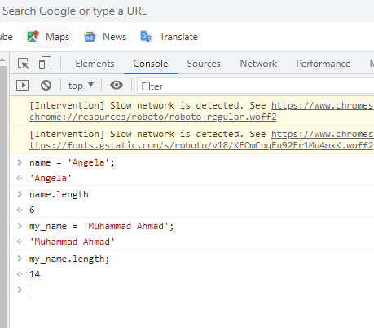

<https://charactercounter.com/twitter>

My name is Muhammad Ahmad. I belong to Kasur a nice city of Pakistan. I study in Government College University Lahore, Pakistan. I proud to myself for educating from one of the best universities in the world.

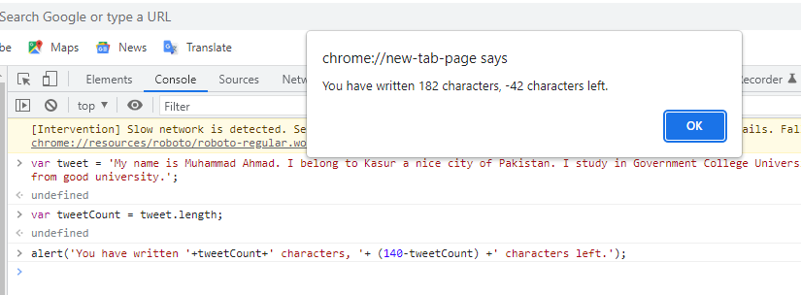

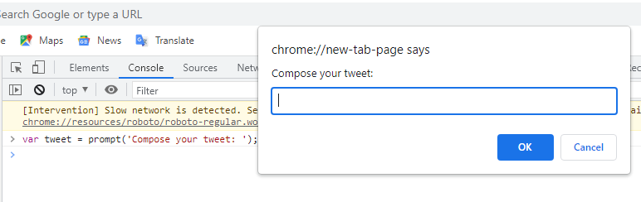

If you don’t compose your tweet then run tweet.length command then you will found errors.

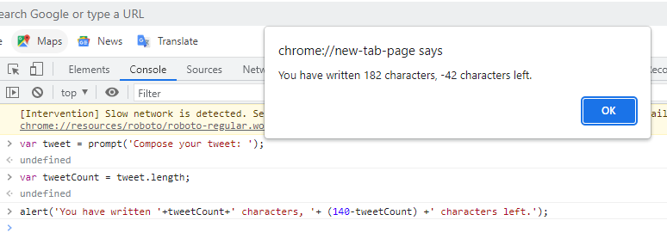

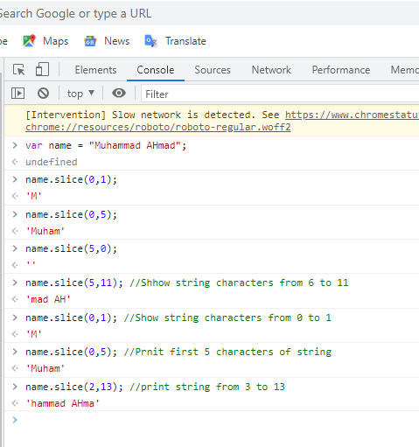

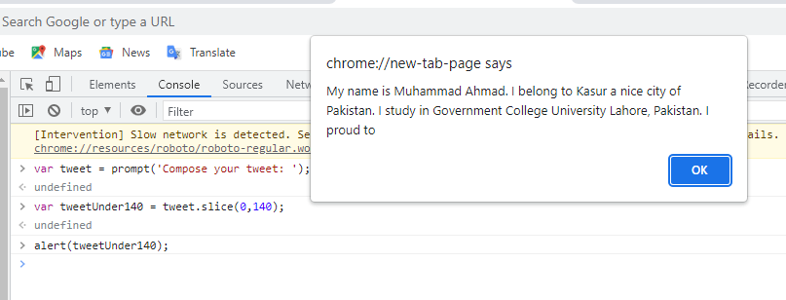

This shows tweet of length 0 to 140 characters.

But real tweet length is 182.

My name is Muhammad Ahmad. I belong to Kasur a nice city of Pakistan. I study in Government College University Lahore, Pakistan. I proud to myself for educating from good university.